**Documentation for Blog_Application**

Create Project -Blog Application

software required: Visual studio and pgadmin

1. create new project.

2. install packages-to connect database using entity framework

microsoft.entityframeworkcore.tools

microsoft.entityframeworkcore.design

npgsql.entityframeworkcore.postgresql

3. create model class-dabContext class and blog post class with following properties:Id, Title, Content, DateCreated, and DateModified.

4. add connection string in appsettings.

5. resgister in program.cs .

6. run migration.

7. create controller- add methods

8. create view : postlist-showing blog post using kendo grid with popup edit and delete functionality.

9. create view : CreatePost-creating blog post.

This application create,edit,delete and display blog post.

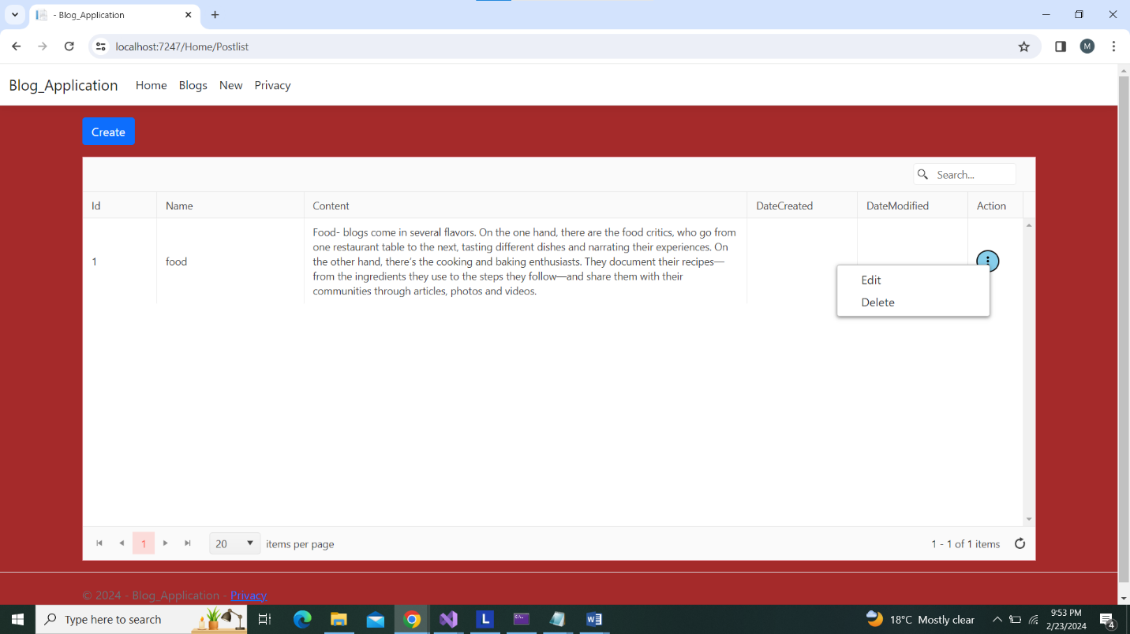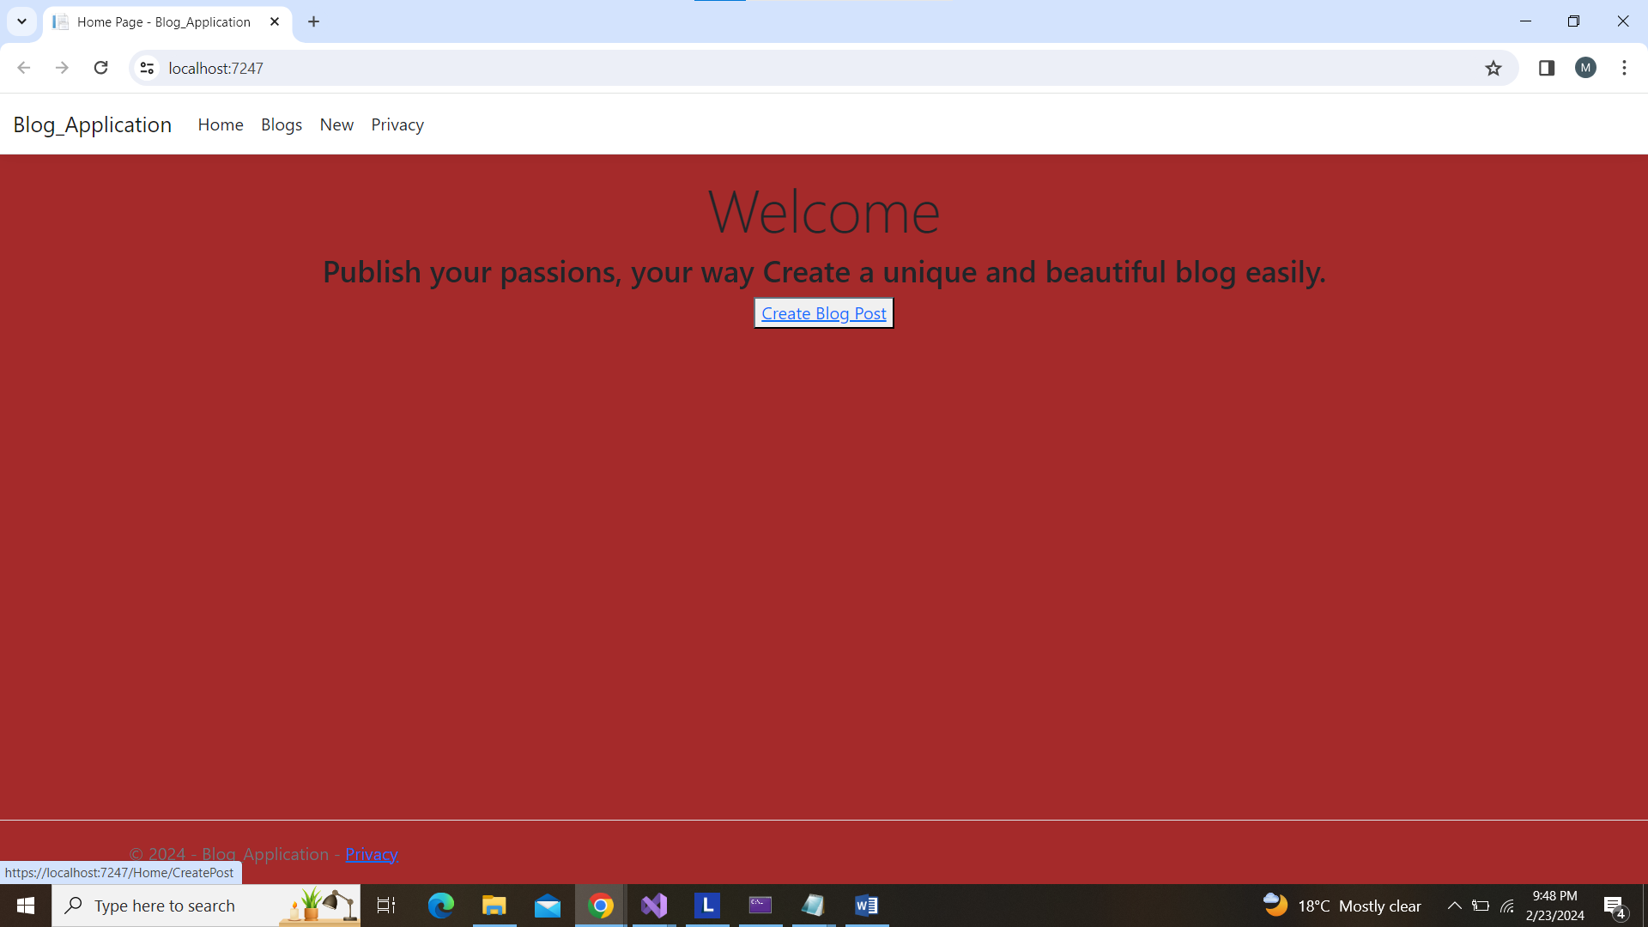

List of Blog post

Add new Post  
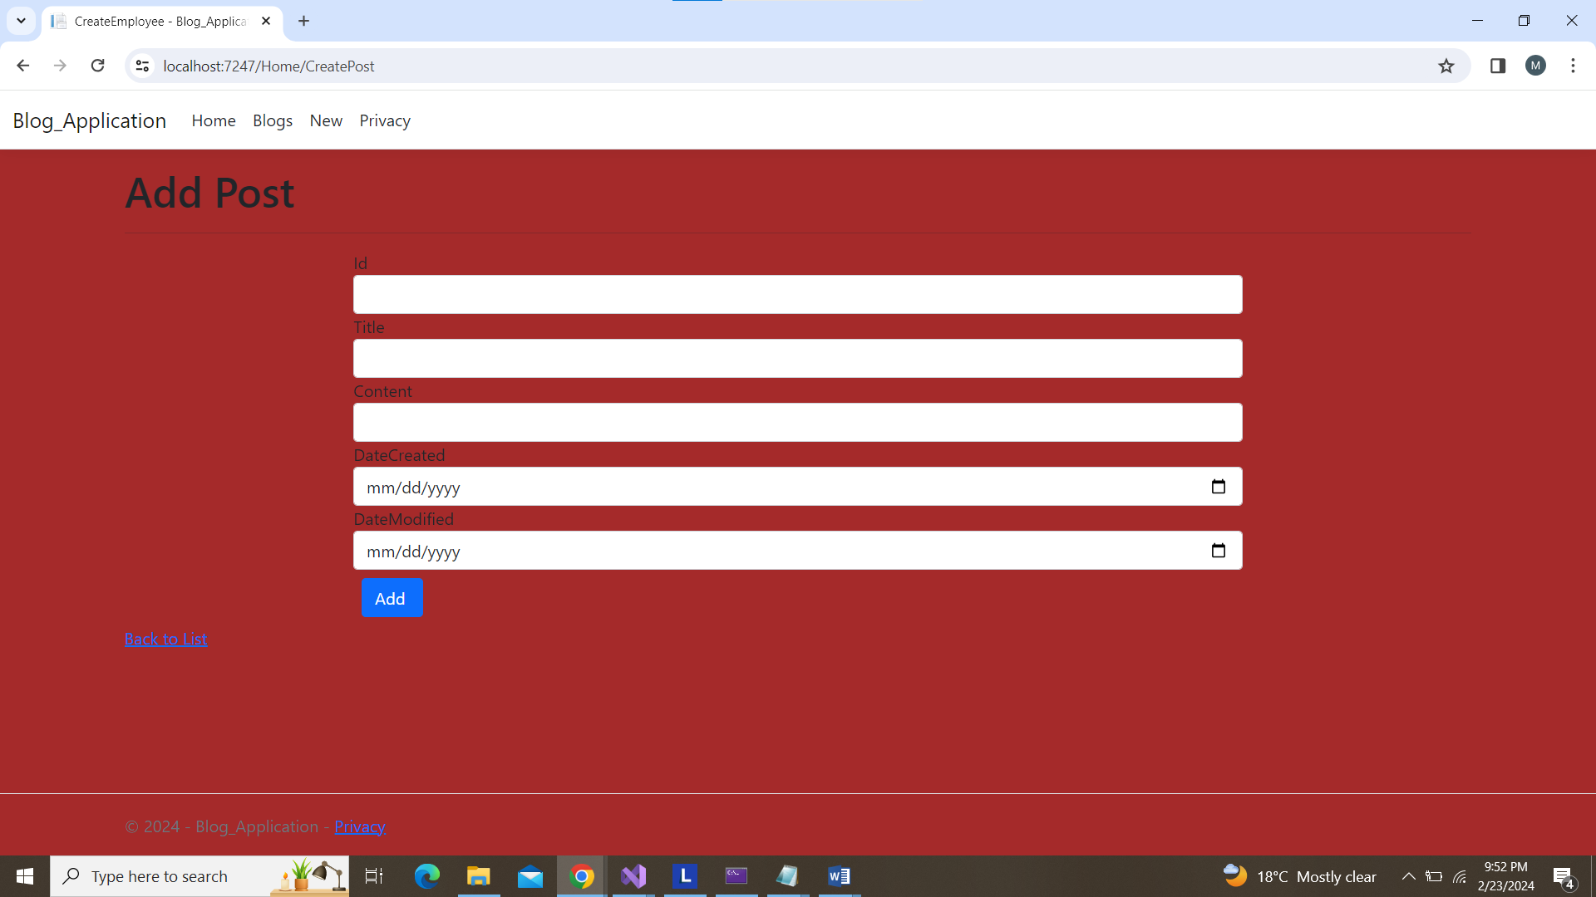

Edit post

